Trees, Stars, and Multiple Biological Sequence Alignment
Stephen F. Altschul and David J. Lipman
SIAM J. APPL. MATH. Vol. 49, pp. 197-209, February 1989
Abstract (Abstract Title)
A new algorithm is proposed to allow K simultaneous entries into a critical section in a distributed system. (Section Content)
- Review of Carrillo and Lipman’s algorithm.
The central idea of Carrillo and Lipman’s algorithm is that the cost of the projection of an optimal multiple alignments onto two of its sequences must be at least as great as the distance between these sequences.
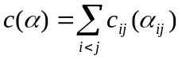
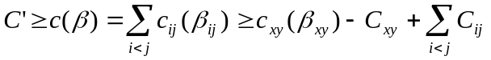
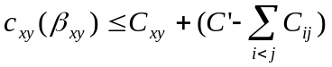
- Tree-alignments.
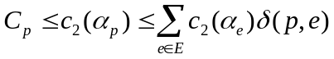
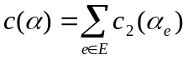
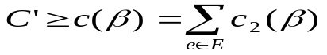
- Star-alignments.
Lemma 1. For a star-alignment, any vertex of the convex polyhedron defined by the equations (11) and (12) has all coordinates 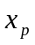 equal to zero, , or one.
Theorem 1. In the feasible region corresponding to the inequalities (10) to (12) implied by a star, there always exists a vertex v minimizing (16) sych that the following hold:
- The two nodes of G(v) corresponding to the sequences of pair q are adjacent.
- If the star has three edges, G(v) is either a cycle of size three, or a cycle of size two and an isolated node.
- If the star has more than three edges, G(v) consists of cycles of size odd or equal to two
Created by : Rei-Sing Cheng
Date : May 9, 2002

